1.DATA PREPROCESSIN

To Create a program for Create Dataset in csv file with 10 rows and 5 columns with Name, age, Height, Weight, BP, Load the CSV file and preprocessing the Data. i) Range Normalization , ii) predict missing values(if any) ,iii) select the useful feautres automatically, iv) print he preprocessed data.

Code:
Matplotlib inline:
import matplotlib.pyplot as plt import numpy as np
import warnings warnings.simplefilter('ignore',DeprecationWarning) arr=np.array([10,20,30,40,50])
arr_stand=(arr-arr.mean())/arr.std() print(arr_stand)
Output:

Standard scaler:
from sklearn.preprocessing import StandardScaler scaler=StandardScaler() scaler.fit_transform(arr.reshape(-1,1)) scaler.fit_transform(arr.reshape(-1,1))

Output:
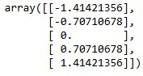

Minmax scaler
from sklearn.preprocessing import MinMaxScaler min_max=MinMaxScaler() min_max.fit_transform(arr.reshape(-1,1)) Output:
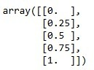

Dataset with 5 features:
import pandas as pd
from pandas import DataFrame data={'Name':['Gokul','Minato','Naruto','Kira','Eren'], 'Age':[20,40,25,25,20],
'Height':[170,180,110,150,125],
'Weight':[55,60,65,60,55],
'BP':[0,100,65,70,40]}
frame=pd.DataFrame(data) print('\n',frame)
frame.to_csv('paitent_data.csv',index=False) df=pd.read_csv('paitent_data.csv') print('\n',df)
df=df.replace(0, df.mean(numeric_only=True)) print('\n',df) frame2=df[['Age','BP','Height','Weight']] print('\n',frame2)
scaler.fit(frame2) scaled=scaler.transform(frame2) print('\n',scaled)
scaled.shape
print('\n','mean=%s' % scaled.mean(axis=0))

print('\n','standard deviation:%s'%scaled.std(axis=0)) frame3=df[['Age','BP','Height','Weight']] min_max.fit(frame3) scaled2=min_max.transform(frame3)
print('\n',scaled2) print('\n','mean:%s'%scaled2.mean(axis=0)) print('\n','standard deviation:5s'%scaled2.std(axis=0)) from sklearn.feature_selection import VarianceThreshold sel=VarianceThreshold(threshold=(.5*(1-.9))) useful_features1 = sel.fit_transform(scaled) print('\n','useful Feature values based on StandardScaler' ) print('\n',useful_features1)
useful_features2 = sel.fit_transform(scaled2) print('\n','Useful feature values based on minmaxscaler') print('\n',useful_features2)

Output:
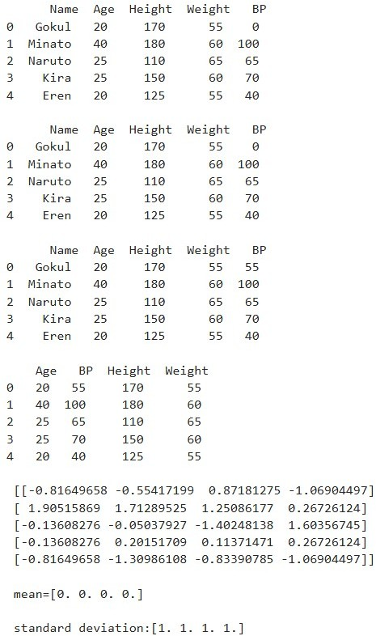

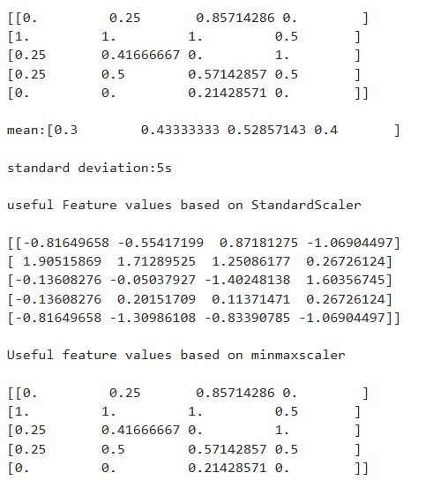

Extra credits:
- Unfortunately it selects all features as important features. Change the variance threshold and try to eliminate useless features, if any.
import pandas as pd
from sklearn.feature_selection import VarianceThreshold sel_new = VarianceThreshold(threshold=0.8) new_useful_features_std = sel_new.fit_transform(scaled) print('\nAfter Increasing Threshold (StandardScaler) ') print('\nUseful feature matrix:\n', new_useful_features_std) cols = ['Age','BP','Height','Weight']
remaining_std = [cols[i] for i, kept in enumerate(sel_new.get_support()) if kept] print('\nUseful features (StdScaler):', remaining_std)

Output:
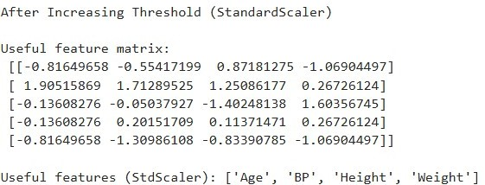

- Display the name of a patient whose BP is more than 75:
bp_filtered = df[df["BP"] > 75]["Name"] print('\n Patients with BP > 75 ') print('\n',bp_filtered.tolist())

Output:
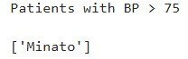
- In addition to existing attributes in 'data', add an attribute 'sugar-level' with values 110, 135, 200, 140, 170 for those 5 patients:
df["sugar-level"] = [110, 135, 200, 140, 170] print('\n After Adding Sugar-level Column ') print('\n',df)

Output:
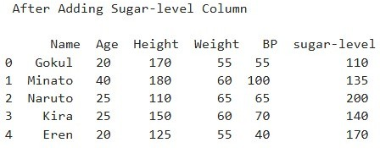
- Display name of patients whose sugar-level is greater than 150:
sugar_filtered = df[df["sugar-level"] > 150]["Name"] print('\n Patients with Sugar-level > 150 ') print('\n',sugar_filtered.tolist())

Output:
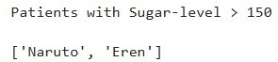

- Now observe all useful features:
frame4 = df[['Age','BP','Height','Weight','sugar-level']] from sklearn.preprocessing import StandardScaler scaler2 = StandardScaler()
scaled_all = scaler2.fit_transform(frame4) sel_final = VarianceThreshold(threshold=0.8) final_useful = sel_final.fit_transform(scaled_all)
print('\n Useful Features After Adding Sugar-level ') print('\n',final_useful)
cols2 = ['Age','BP','Height','Weight','sugar-level']
remaining_final = [cols2[i] for i, kept in enumerate(sel_final.get_support()) if kept] print('\n Final useful features:', remaining_final)

Output:
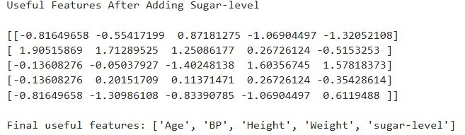

- LINEAR REGRESSION
To Create a program for Generate random numbers for input features and target. Divide the data into training and testing set. Print the training and testing data. Create a linear regression model for the dataset and run the model for 100 iterations. Print the evaluation results and learned model weights.

Code:
import matplotlib.pyplot as plt import numpy as np
from sklearn.linear_model import LinearRegression from sklearn.linear_model import SGDRegressor
x = np.array([1,2,4,3,5])
y = np.array([1,3,4,3,7]) print('\n',x.shape)
print('\n',y.shape)
print('\n',x)
print('\n',y)
x = x.reshape(-1,1) print('\n',x.shape)
print('\n',x)
model = LinearRegression() model.fit(x, y) print(model.predict([[8]])) y_pred = model.predict(x)
plt.scatter(x, y, color='r', marker='o') plt.plot(x, y_pred, color='b', linewidth=2) plt.xlabel('x')
plt.ylabel('y') plt.show() print('\n',model.coef_)
print('\n',model.intercept_)
from sklearn.preprocessing import StandardScaler scaler = StandardScaler()

x_stand = scaler.fit_transform(x.astype(float))
sgdr = SGDRegressor(penalty='l2', alpha=0.15, max_iter=100) sgdr.fit(x_stand, y)
print(sgdr.predict([[10]])) y_pred2 = sgdr.predict(x_stand)
plt.scatter(x_stand, y, color='g', marker='o') plt.plot(x_stand, y_pred2, color='b', linewidth=2) plt.xlabel('x_normalized')
plt.ylabel('y') plt.show() print(sgdr.coef_) print(sgdr.intercept_)

Output:
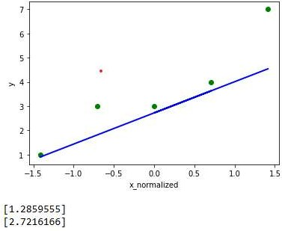
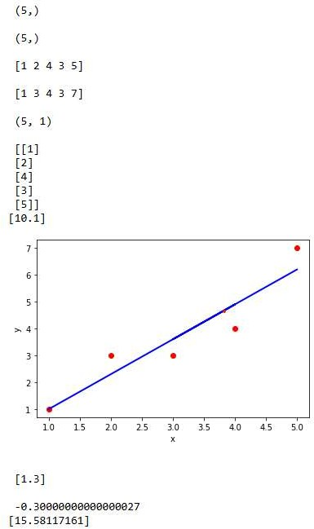

Extra credits:
- Read the car price prediction dataset.
- Rerun Linear Regression model and print scatter plot
- Show again model coefficient and intercept values
- Rerun SGD Regressor model again and print scatter plot
- Print its weights and intercept values

Code:
import pandas as pd import numpy as np
import matplotlib.pyplot as plt
from sklearn.linear_model import LinearRegression from sklearn.linear_model import SGDRegressor data = pd.read_csv("car_data.csv")
print("\nDataset Head:\n", data.head()) x = data['Mileage'].values
y = data['Price'].values print('\nShape of x:', x.shape) print('Shape of y:', y.shape) print('\nx sample:', x[:10])
print('y sample:', y[:10]) x = x.reshape(-1, 1)
print('\nReshaped x:', x.shape) print(x[:10])
model = LinearRegression() model.fit(x, y)
y_pred = model.predict(x) plt.scatter(x, y, color='r', marker='o')
plt.plot(x, y_pred, color='b', linewidth=2) plt.xlabel('Mileage')
plt.ylabel('Price')
plt.title('Linear Regression - Car Price Prediction')

plt.show()
print("\nLinear Regression Coefficient:", model.coef_) print("Linear Regression Intercept:", model.intercept_) sgdr = SGDRegressor(max_iter=100)
sgdr.fit(x, y) y_pred2 = sgdr.predict(x) plt.scatter(x, y, color='g', marker='o') plt.plot(x, y_pred2, color='b', linewidth=2) plt.xlabel('Mileage')
plt.ylabel('Price')
plt.title('SGD Regression - Car Price Prediction') plt.show()
print("\nSGD Coefficient:", sgdr.coef_) print("SGD Intercept:", sgdr.intercept_)

Output:
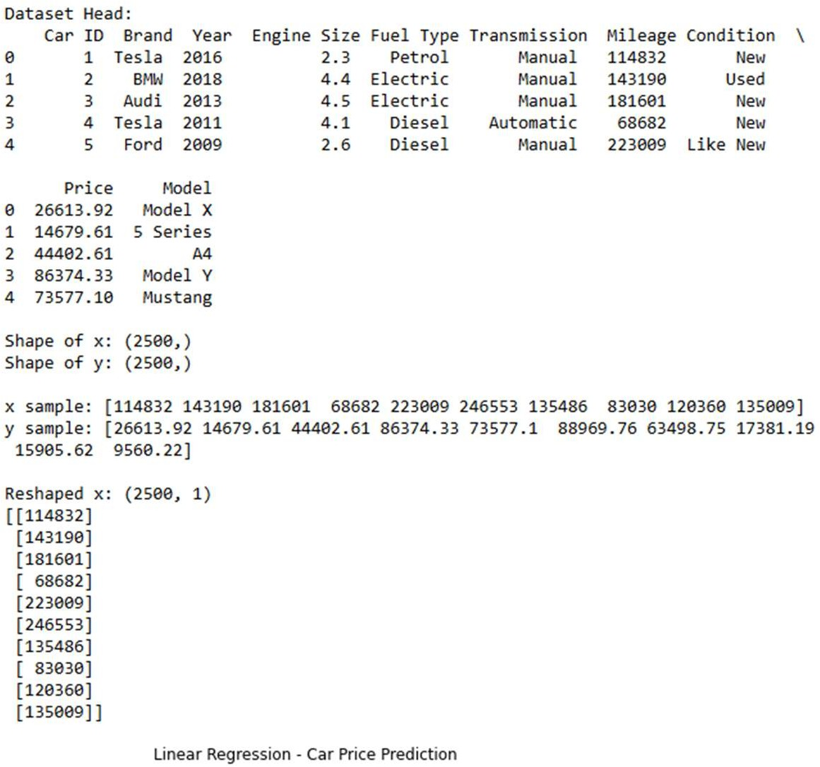
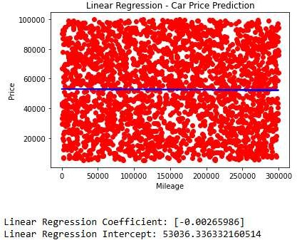
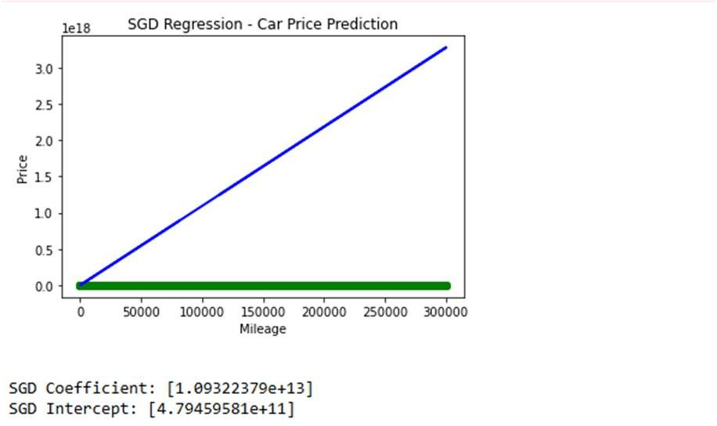

- MULTIPLE LINEARREGRESSION
To create a program for Load the boston house price prediction dataset. Divide the data into training and testing set. Print the training and testing data. Create a multiple linear regression model for the dataset and run the model for 500 iterations. Print the evaluation results and learned model weights.

Code:
import matplotlib.pyplot as plt import numpy as np
import pandas as pd
from sklearn.linear_model import LinearRegression from sklearn.model_selection import train_test_split from sklearn import datasets
from sklearn import metrics
from sklearn.datasets import fetch_california_housing boston = fetch_california_housing() print(boston.data.shape)
print(boston.target.shape) print(boston.feature_names)
df = pd.DataFrame(boston.data) print(df.head())
df.columns = boston.feature_names print(df.head(2)) print(boston.target.shape) df['PRICE'] = boston.target print(df.head(2))
df.describe()
X_train, X_test, y_train, y_test = train_test_split(boston.data, boston.target, test_size=0.10, random_state=42)
print(X_train.shape) print(X_test.shape) print(y_train.shape) print(y_test.shape)

model = LinearRegression() model.fit(X_train, y_train) print(model.coef_)
print('Intercept: %.3f' % model.intercept_) y_pred = model.predict(X_test) print(y_pred[:5]) #first 5 predictions print(y_test[:5]) #first 5 target values plt.scatter(y_test, y_pred) plt.xlabel('Price')
plt.ylabel('Predicted Price')
plt.title('Boston House Price vs Predicted Price')
print('R-squared value on training dataset: %0.3f' %model.score(X_train, y_train)) print('R-squared value on training dataset: %0.3f' %model.score(X_test, y_test)) print('Mean Absolute Error: %0.3f' %metrics.mean_absolute_error(y_test, y_pred)) print('Mean Squared Error: %0.3f' %metrics.mean_squared_error(y_test, y_pred)) print('Root Mean Squared Error: %0.3f' %np.sqrt(metrics.mean_squared_error(y_test, y_pred)))
mean = np.mean(y_test)
print('10% of Mean value of target: {:0.3f}'.format(np.mean(y_test)*0.1))

Output:
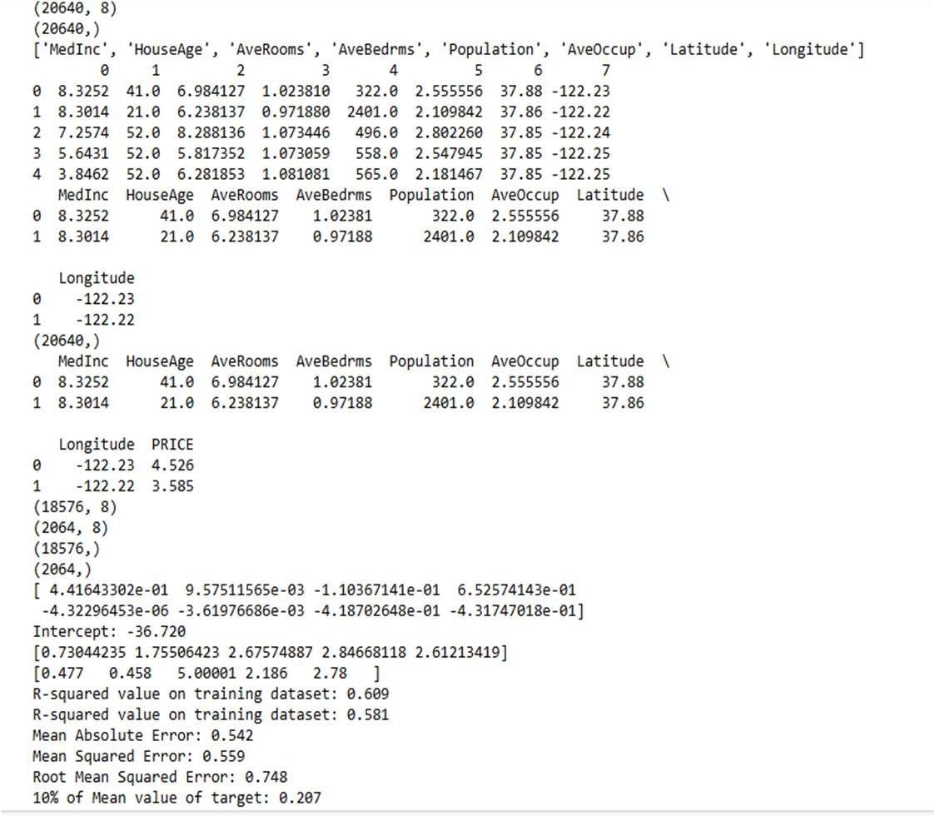
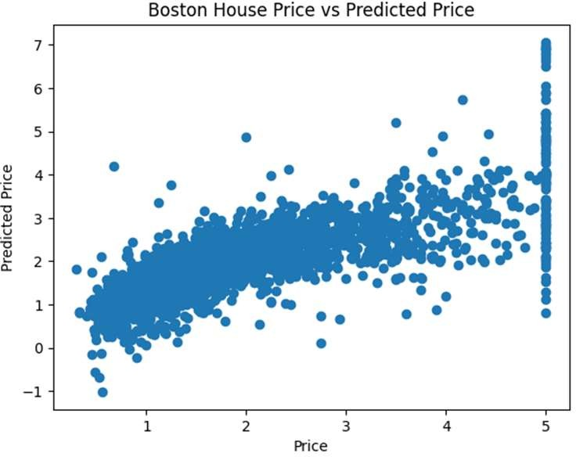

Extra credits:
- Normalize your data using StandardScaler and rerun LinearRegression. Create a new Scatter plot for the scaled y_test vs y_pred. Compute the scores for scaled X_train and X_test. Compute mean squared error.
- Change the size of the test set to 20% instead of 10%. Rerun the model, print scatter plot and compute error values. Whether error values reduce or not?

Code:
import matplotlib.pyplot as plt import numpy as np
import pandas as pd
from sklearn.linear_model import LinearRegression from sklearn.model_selection import train_test_split from sklearn import metrics
from sklearn.datasets import fetch_california_housing from sklearn.preprocessing import StandardScaler boston = fetch_california_housing()
print("Data shape:", boston.data.shape) print("Target shape:", boston.target.shape) print("Feature names:", boston.feature_names)
df = pd.DataFrame(boston.data, columns=boston.feature_names) df['PRICE'] = boston.target
print(df.head(2)) print(df.describe())
X_train, X_test, y_train, y_test = train_test_split( boston.data, boston.target, test_size=0.10, random_state=42) model = LinearRegression()
model.fit(X_train, y_train) y_pred = model.predict(X_test) plt.scatter(y_test, y_pred) plt.xlabel('Price') plt.ylabel('Predicted Price')
plt.title('California House Price vs Predicted Price (10% Test)')

plt.show()
print("Original Linear Regression (10% Test)")
print("R-squared on train:", model.score(X_train, y_train)) print("R-squared on test:", model.score(X_test, y_test))
print("Mean Absolute Error:", metrics.mean_absolute_error(y_test, y_pred)) print("Mean Squared Error:", metrics.mean_squared_error(y_test, y_pred))
print("Root Mean Squared Error:", np.sqrt(metrics.mean_squared_error(y_test, y_pred))) scaler = StandardScaler()
X_scaled = scaler.fit_transform(boston.data)
X_train_s, X_test_s, y_train_s, y_test_s = train_test_split( X_scaled, boston.target, test_size=0.10, random_state=42) model_scaled = LinearRegression() model_scaled.fit(X_train_s, y_train_s)
y_pred_s = model_scaled.predict(X_test_s) plt.scatter(y_test_s, y_pred_s) plt.xlabel('Price')
plt.ylabel('Predicted Price')
plt.title('California House Price vs Predicted Price (Scaled Data)') plt.show()
print("\nLinear Regression with Scaled Data (10% Test)")
print("R-squared on train:", model_scaled.score(X_train_s, y_train_s)) print("R-squared on test:", model_scaled.score(X_test_s, y_test_s))
print("Mean Absolute Error:", metrics.mean_absolute_error(y_test_s, y_pred_s)) print("Mean Squared Error:", metrics.mean_squared_error(y_test_s, y_pred_s))
print("Root Mean Squared Error:", np.sqrt(metrics.mean_squared_error(y_test_s, y_pred_s))) X_train_20, X_test_20, y_train_20, y_test_20 = train_test_split(
boston.data, boston.target, test_size=0.20, random_state=42) model_20 = LinearRegression()
model_20.fit(X_train_20, y_train_20) y_pred_20 = model_20.predict(X_test_20) plt.scatter(y_test_20, y_pred_20) plt.xlabel('Price')

plt.ylabel('Predicted Price')
plt.title('California House Price vs Predicted Price (20% Test)') plt.show()
print("\nLinear Regression (20% Test)")
print("R-squared on train:", model_20.score(X_train_20, y_train_20)) print("R-squared on test:", model_20.score(X_test_20, y_test_20))
print("Mean Absolute Error:", metrics.mean_absolute_error(y_test_20, y_pred_20))
print("Mean Squared Error:", metrics.mean_squared_error(y_test_20, y_pred_20))
print("Root Mean Squared Error:", np.sqrt(metrics.mean_squared_error(y_test_20, y_pred_20)))
original_mse = metrics.mean_squared_error(y_test, y_pred) new_mse = metrics.mean_squared_error(y_test_20, y_pred_20)
print("\nMSE change from 10% test to 20% test:", new_mse - original_mse)

Output:
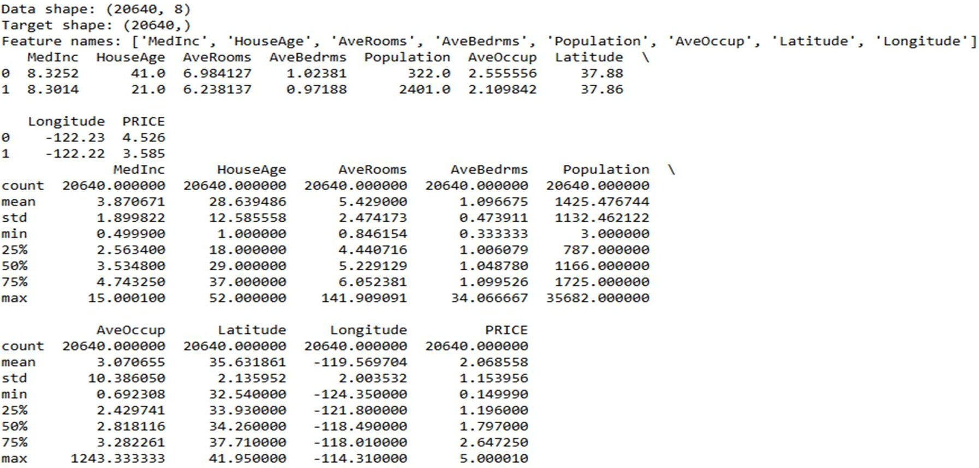
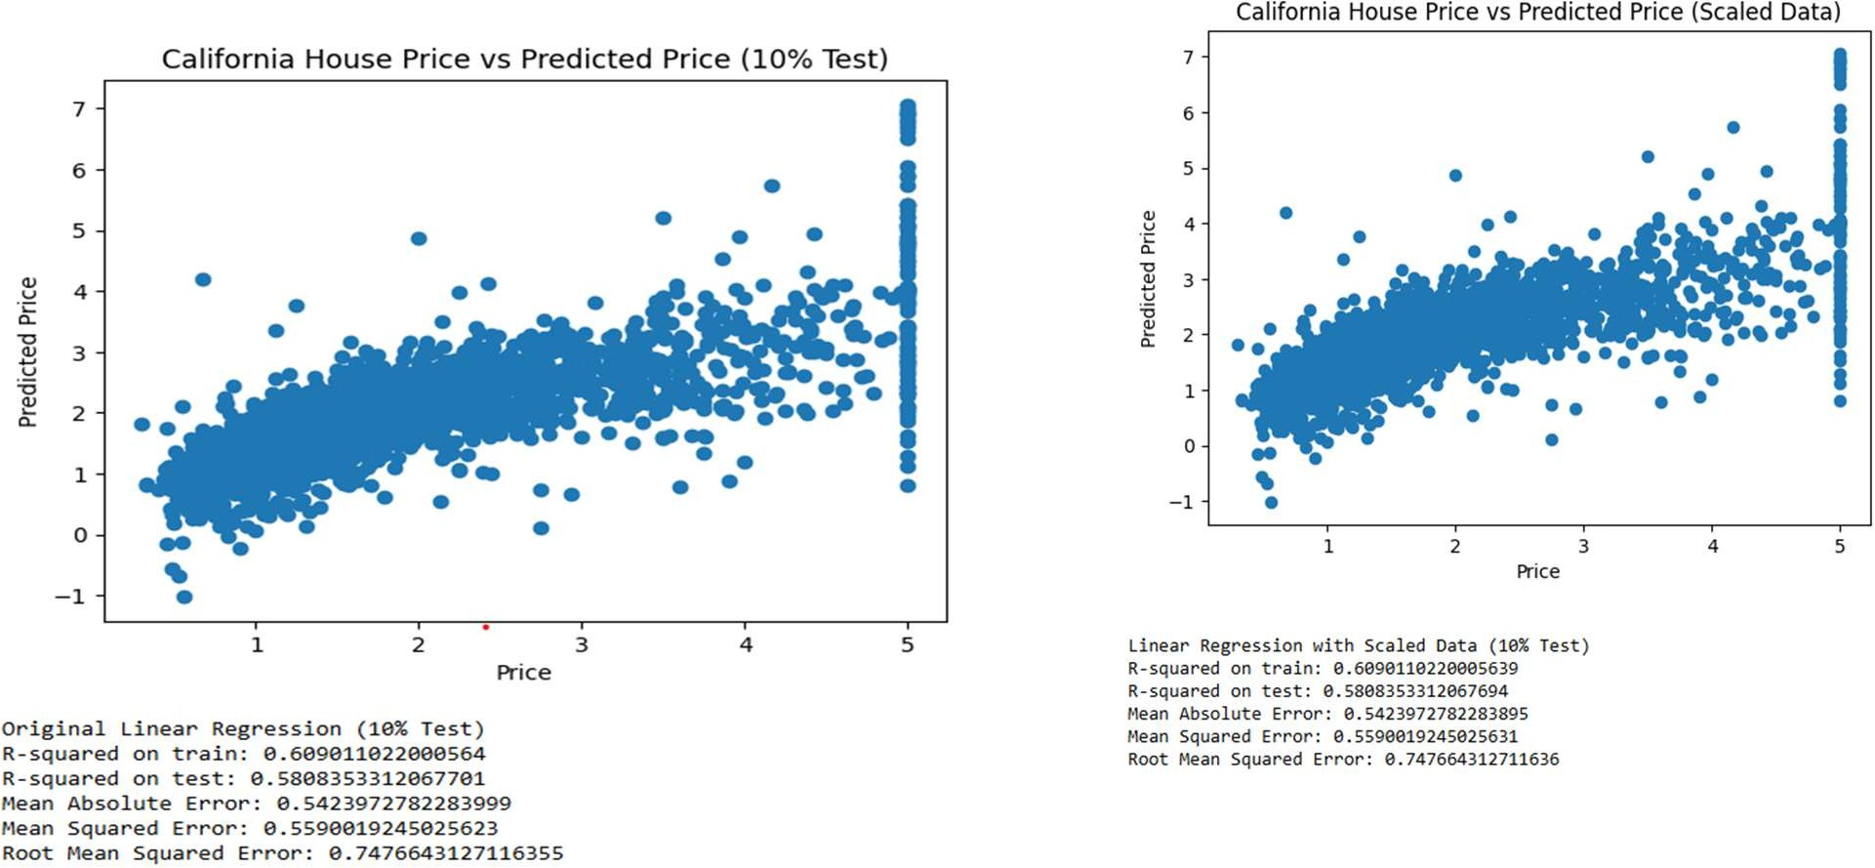

- LOGISTIC REGRESSION
To create a program for load the iris classification dataset. Divide the data into training and testing set. Print the training and testing data. Create a logistic regression mode for the dataset and run the model for 500 iterations. Print the evaluation results and learned model weights.

Code:
import matplotlib.pyplot as plt import numpy as np
import warnings
warnings.simplefilter("ignore", DeprecationWarning) from sklearn.datasets import load_iris
from sklearn.model_selection import train_test_split from sklearn.linear_model import LogisticRegression from sklearn.preprocessing import StandardScaler data = load_iris()
X, y = data.data, data.target
X_train, X_test, y_train, y_test = train_test_split(X, y, test_size=0.2, random_state=42) print("Training Data:")
print(X_train) print("Testing Data:") print(X_test)
scaler = StandardScaler()
X_train_scaled = scaler.fit_transform(X_train) X_test_scaled = scaler.transform(X_test) model = LogisticRegression(max_iter=500) model.fit(X_train_scaled, y_train)
y_pred = model.predict(X_test_scaled) accuracy = model.score(X_test_scaled, y_test) print("Model Accuracy:", accuracy) print("Learned Model Weights:") print(model.coef_)

Output:
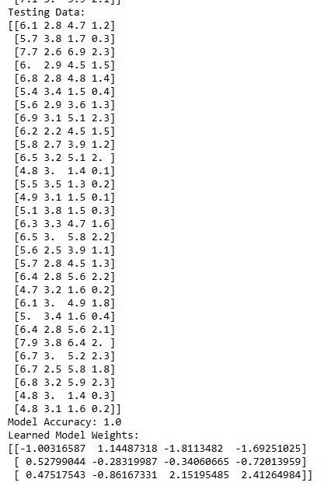
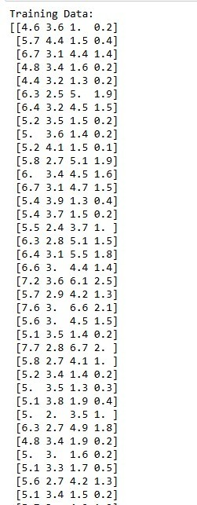

Extra credits:

- Print the confusion matrix for model predictions
- Display classification report
- Visualize the feature importance using model coefficients
- Experiment with different test sizes (e.g., 30%, 40%) and compare accuracy
- Save the trained model and load it for prediction

Code:
import matplotlib.pyplot as plt import numpy as np
import warnings import pickle
from sklearn.datasets import load_iris
from sklearn.model_selection import train_test_split

from sklearn.linear_model import LogisticRegression from sklearn.preprocessing import StandardScaler
from sklearn.metrics import confusion_matrix, classification_report, ConfusionMatrixDisplay warnings.simplefilter("ignore", DeprecationWarning)
data = load_iris()
X, y = data.data, data.target
def train_evaluate(test_size=0.2):
X_train, X_test, y_train, y_test = train_test_split(X, y, test_size=test_size, random_state=42) scaler = StandardScaler()
X_train_scaled = scaler.fit_transform(X_train) X_test_scaled = scaler.transform(X_test) model = LogisticRegression(max_iter=500) model.fit(X_train_scaled, y_train)
y_pred = model.predict(X_test_scaled) accuracy = model.score(X_test_scaled, y_test)
print(f"\n--- Test Size: {int(test_size*100)}% ---") print("Model Accuracy:", accuracy)
# Extra Credit 1: Confusion Matrix
cm = confusion_matrix(y_test, y_pred) print("\nConfusion Matrix:")
print(cm)
ConfusionMatrixDisplay(cm, display_labels=data.target_names).plot(cmap=plt.cm.Blues) plt.show()
print("\nClassification Report:")
print(classification_report(y_test, y_pred, target_names=data.target_names)) feature_importance = model.coef_
plt.figure(figsize=(8,5))
for i, class_name in enumerate(data.target_names):
plt.bar(np.arange(X.shape[1]) + i*0.2, feature_importance[i], width=0.2, label=class_name) plt.xticks(np.arange(X.shape[1]), data.feature_names, rotation=45)
plt.ylabel("Coefficient Value")
plt.title("Feature Importance (Model Coefficients)")

plt.legend() plt.show()
return model, scaler models = {}
for ts in [0.2, 0.3, 0.4]:
model, scaler = train_evaluate(test_size=ts) models[ts] = (model, scaler)
# Extra Credit 5: Save the model and scaler with open("iris_model.pkl", "wb") as f: pickle.dump(models[0.2][0], f)
with open("iris_scaler.pkl", "wb") as f: pickle.dump(models[0.2][1], f)
# Load the model and make a prediction with open("iris_model.pkl", "rb") as f:
loaded_model = pickle.load(f)
with open("iris_scaler.pkl", "rb") as f:
loaded_scaler = pickle.load(f)
sample = np.array([[5.1, 3.5, 1.4, 0.2]]) # Example iris features sample_scaled = loaded_scaler.transform(sample)
pred_class = loaded_model.predict(sample_scaled)
print("\nPrediction for sample input:", data.target_names[pred_class[0]])
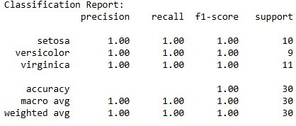
Output:
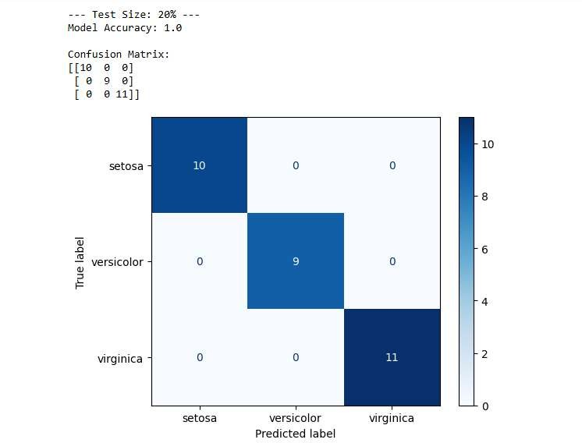
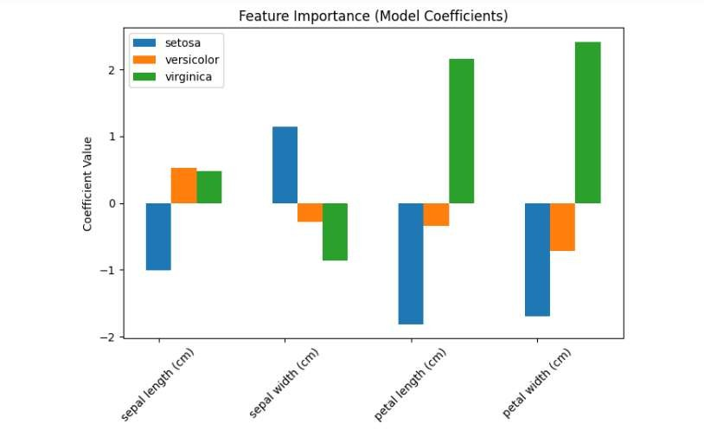

- SUPPORT VECTOR MACHINE
To create a program for Load the digits classification dataset. Divide the data into training and testing set. Print the training and testing data. Create a linear svm model for the dataset and run the model for 500 iterations. Apply logistic regression to the dataset and print the results. Print the evaluation results and learned model weights. Compare the results with results of logistics regression in terms of speed and accuracy.

Code:
import matplotlib.pyplot as plt import numpy as np
import warnings
warnings.simplefilter("ignore", DeprecationWarning) from sklearn.datasets import load_digits
from sklearn.model_selection import train_test_split from sklearn.linear_model import LogisticRegression from sklearn.svm import SVC
from sklearn.preprocessing import StandardScaler
from sklearn.metrics import accuracy_score, classification_report, confusion_matrix import seaborn as sns
data = load_digits()
X, y = data.data, data.target
X_train, X_test, y_train, y_test = train_test_split( X, y, test_size=0.2, random_state=42) print("Training Data:")
print(X_train) print("\nTesting Data:")
print(X_test) scaler = StandardScaler() X_train_scaled = scaler.fit_transform(X_train) X_test_scaled = scaler.transform(X_test)
svm_model = SVC(kernel='linear', max_iter=500, probability=True) svm_model.fit(X_train_scaled, y_train)
y_pred_svm = svm_model.predict(X_test_scaled)

svm_accuracy = accuracy_score(y_test, y_pred_svm) print("\nSVM Model Accuracy:", svm_accuracy) print("SVM Classification Report:") print(classification_report(y_test, y_pred_svm)) print("SVM Confusion Matrix:") print(confusion_matrix(y_test, y_pred_svm)) logistic_model = LogisticRegression(max_iter=500) logistic_model.fit(X_train_scaled, y_train) y_pred_logistic = logistic_model.predict(X_test_scaled)
logistic_accuracy = accuracy_score(y_test, y_pred_logistic) print("\nLogistic Regression Model Accuracy:", logistic_accuracy) print("Logistic Regression Classification Report:") print(classification_report(y_test, y_pred_logistic))
print("Logistic Regression Confusion Matrix:") print(confusion_matrix(y_test, y_pred_logistic)) print("\nLearned Model Weights:") print(logistic_model.coef_) print("\nComparison of Models:")
print(f"SVMAccuracy: {svm_accuracy}, Logistic Regression Accuracy: {logistic_accuracy}") feature_importance = np.abs(logistic_model.coef_).mean(axis=0)
plt.figure(figsize=(12,5)) sns.barplot(x=np.arange(len(feature_importance)), y=feature_importance) plt.xlabel("Feature Index")
plt.ylabel("Importance")
plt.title("Feature Importance in Logistic Regression") plt.show()

Output:
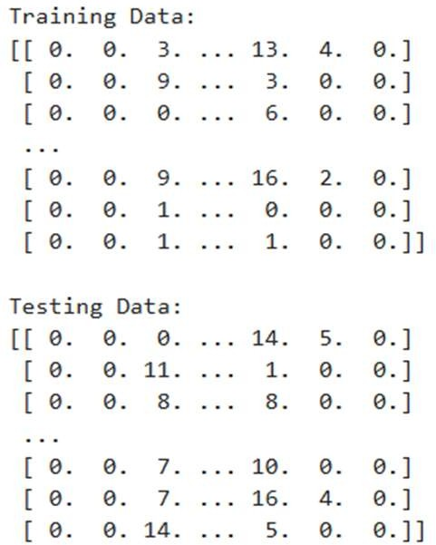

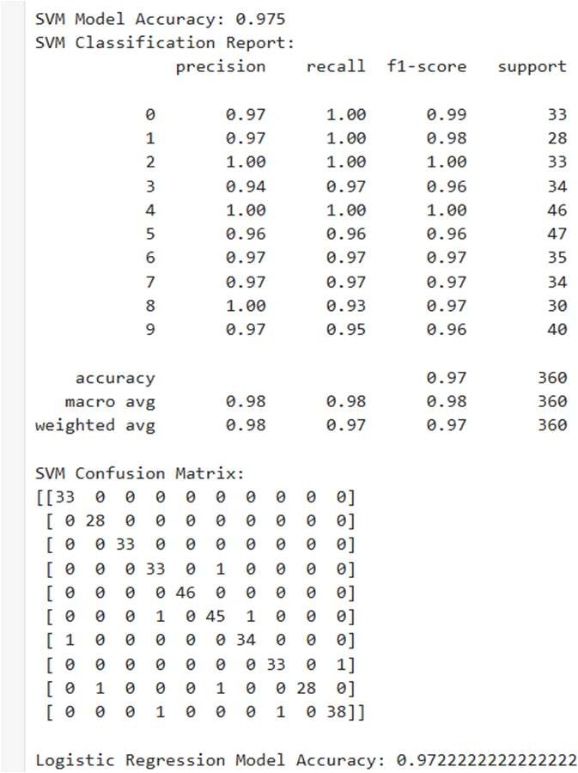
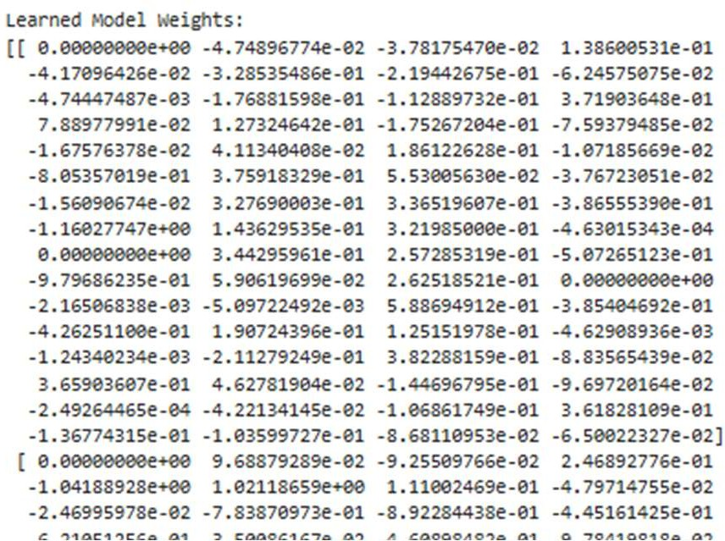
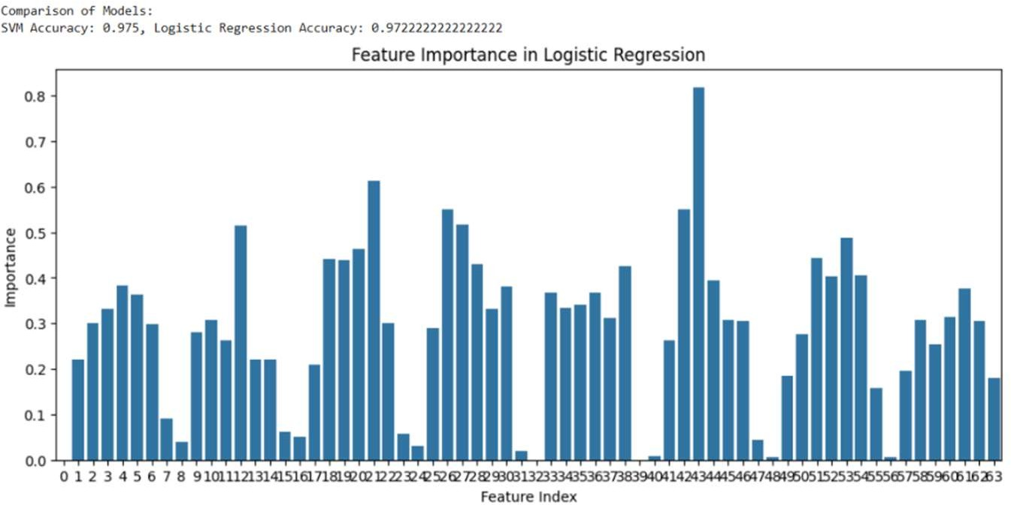

Extra credits:
- Compute and plot ROC curves for both models
- Save and load both models
- Experiment with different SVM kernels (poly, rbf) and compare results
- Compute training time for both models
- Display misclassified samples

Code:
import numpy as np
import matplotlib.pyplot as plt import time
import joblib import warnings
warnings.filterwarnings("ignore"
from sklearn.datasets import load_digits
from sklearn.model_selection import train_test_split
from sklearn.preprocessing import StandardScaler, label_binarize from sklearn.linear_model import LogisticRegression
from sklearn.svm import SVC from sklearn.metrics import ( accuracy_score, classification_report, confusion_matrix, roc_curve,auc)
from sklearn.multiclass import OneVsRestClassifier digits = load_digits()
X = digits.data y = digits.target
X_train, X_test, y_train, y_test = train_test_split( X, y, test_size=0.2, random_state=42)
scaler = StandardScaler()
X_train = scaler.fit_transform(X_train) X_test = scaler.transform(X_test)
lr = LogisticRegression(max_iter=1000) start = time.time()
lr.fit(X_train, y_train) lr_time = time.time() - start y_pred_lr = lr.predict(X_test)
print("Logistic Regression Accuracy:", accuracy_score(y_test, y_pred_lr)) print(confusion_matrix(y_test, y_pred_lr))

print(classification_report(y_test, y_pred_lr)) svm = SVC(kernel='linear')
start = time.time() svm.fit(X_train, y_train) svm_time = time.time() - start
y_pred_svm = svm.predict(X_test)
print("\nSVM (Linear) Accuracy:", accuracy_score(y_test, y_pred_svm)) print(confusion_matrix(y_test, y_pred_svm)) print(classification_report(y_test, y_pred_svm))
print(f"\nTraining Time:")
print(f"Logistic Regression: {lr_time:.4f} seconds") print(f"SVM: {svm_time:.4f} seconds")
y_test_bin = label_binarize(y_test, classes=np.unique(y)) n_classes = y_test_bin.shape[1]
lr_ovr = OneVsRestClassifier(LogisticRegression(max_iter=1000)) y_score = lr_ovr.fit(X_train, y_train).predict_proba(X_test) plt.figure(figsize=(8, 6))
for i in range(n_classes): fpr, tpr, _ = roc_curve(y_test_bin[:, i], y_score[:, i]) roc_auc = auc(fpr, tpr)
plt.plot(fpr, tpr, label=f"Class {i} (AUC={roc_auc:.2f})") plt.title("ROC Curve – Logistic Regression (Multiclass)") plt.xlabel("False Positive Rate")
plt.ylabel("True Positive Rate") plt.legend(loc="lower right", fontsize=8) plt.grid()
plt.show()
joblib.dump(lr, "logistic_model.pkl") joblib.dump(svm, "svm_model.pkl") lr_loaded = joblib.load("logistic_model.pkl") svm_loaded = joblib.load("svm_model.pkl")
print("\nModels saved and loaded successfully!") kernels = ['linear', 'poly', 'rbf']

print("\nSVM Kernel Comparison:") for k in kernels:
svm_k = SVC(kernel=k, gamma='scale') svm_k.fit(X_train, y_train)
y_pred = svm_k.predict(X_test)
acc = accuracy_score(y_test, y_pred) print(f"{k.upper()} kernel accuracy: {acc:.4f}") misclassified = np.where(y_test != y_pred_lr)[0]
plt.figure(figsize=(10, 4)) for i, idx in enumerate(misclassified[:8]): plt.subplot(2, 4, i + 1)
plt.imshow(X_test[idx].reshape(8, 8), cmap='gray') plt.title(f"T:{y_test[idx]} P:{y_pred_lr[idx]}") plt.axis('off')
plt.suptitle("Misclassified Samples – Logistic Regression") plt.show()
Output:
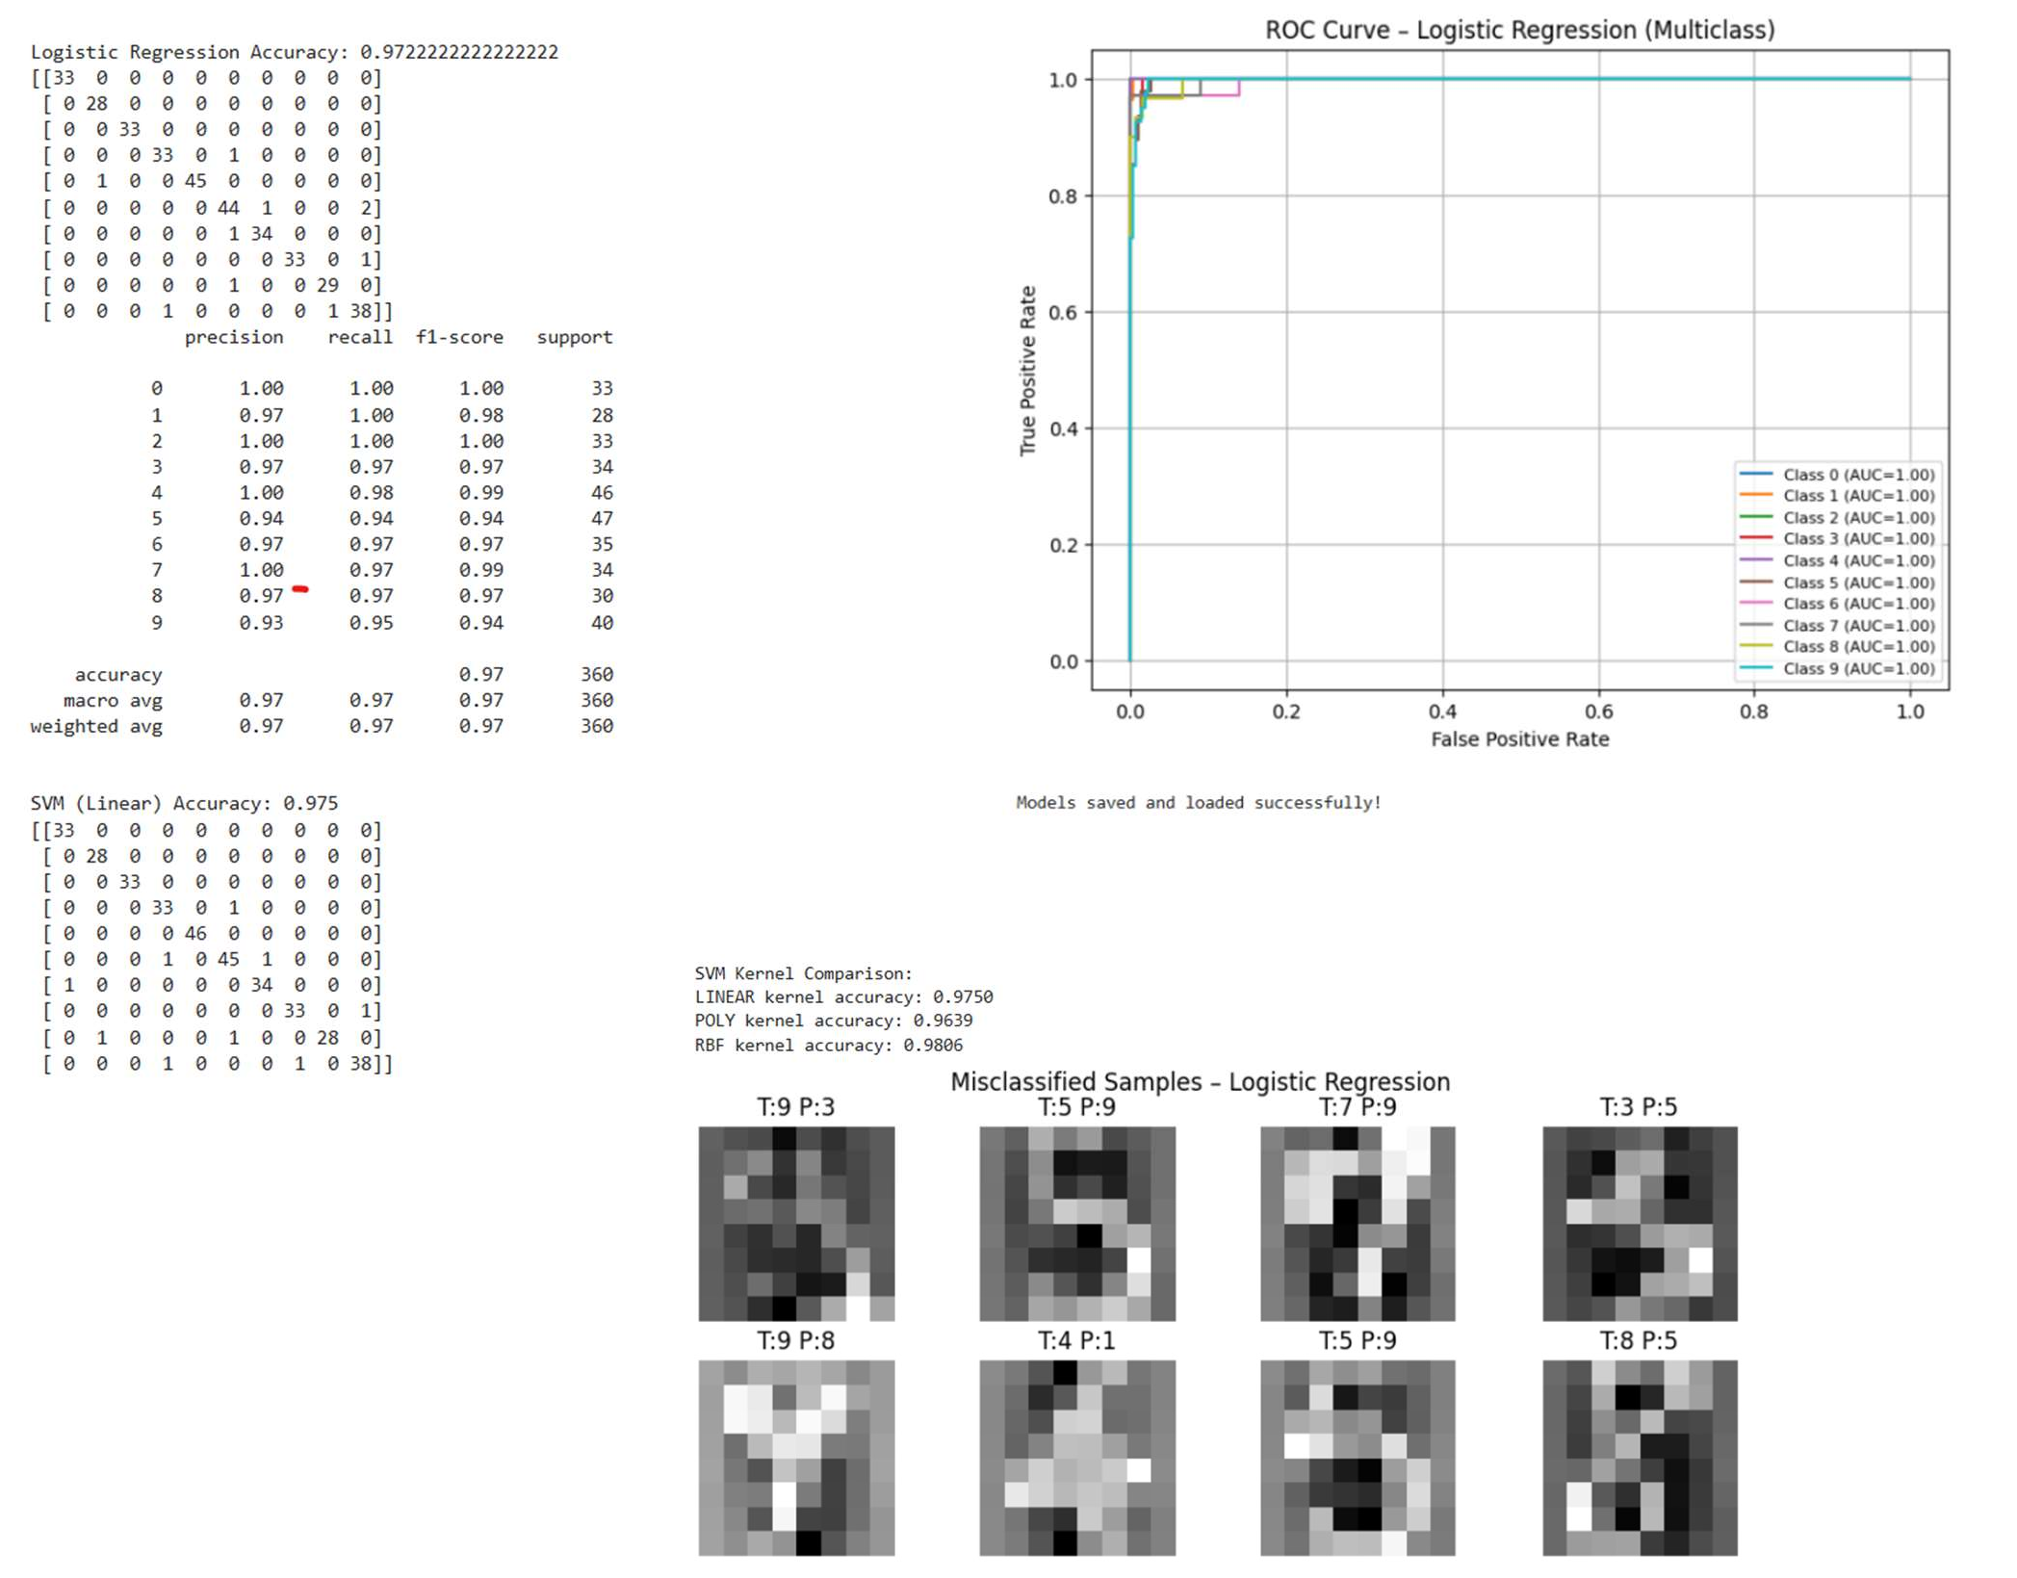

- DECISION TREE CLASSIFIER
To Create a Program for Load the Wine classification dataset. Divide the data into training and testing set. Print the training and testing data. Create a Decision Tree model for the dataset and run the model for 500 iterations. Print the evaluation results and learned model weights. Apply SVM to the dataset and print the results. Compare the results with results of Support Vector machines in terms of speed and accuracy.

Code:
%matplotlib inline
import matplotlib.pyplot as plt import numpy as np
import warnings
warnings.simplefilter("ignore", DeprecationWarning) from sklearn.datasets import load_wine
from sklearn.model_selection import train_test_split from sklearn.tree import DecisionTreeClassifier from sklearn.svm import SVC
from sklearn.preprocessing import StandardScaler
from sklearn.metrics import accuracy_score, classification_report, confusion_matrix import seaborn as sns
import time
data = load_wine()
X, y = data.data, data.target
X_train, X_test, y_train, y_test = train_test_split( X, y, test_size=0.2, random_state=42) print("Training Data:\n", X_train) print("\nTesting Data:\n", X_test)
scaler = StandardScaler()
X_train_scaled = scaler.fit_transform(X_train) X_test_scaled = scaler.transform(X_test)
dt_model = DecisionTreeClassifier(max_depth=10, random_state=42) start_time = time.time()
dt_model.fit(X_train_scaled, y_train)

dt_time = time.time() - start_time
y_pred_dt = dt_model.predict(X_test_scaled) dt_accuracy = accuracy_score(y_test, y_pred_dt) print("\nDecision Tree Model Accuracy:", dt_accuracy) print("\nDecision Tree Classification Report:") print(classification_report(y_test, y_pred_dt)) print("Decision Tree Confusion Matrix:") print(confusion_matrix(y_test, y_pred_dt)) print("Decision Tree Training Time:", dt_time, "seconds") svm_model = SVC(kernel='linear', max_iter=500) start_time = time.time()
svm_model.fit(X_train_scaled, y_train) svm_time = time.time() - start_time
y_pred_svm = svm_model.predict(X_test_scaled) svm_accuracy = accuracy_score(y_test, y_pred_svm) print("\nSVM Model Accuracy:", svm_accuracy) print("\nSVM Classification Report:") print(classification_report(y_test, y_pred_svm)) print("SVM Confusion Matrix:") print(confusion_matrix(y_test, y_pred_svm)) print("SVM Training Time:", svm_time, "seconds") print("\nComparison of Models:")
print(f"Decision Tree Accuracy: {dt_accuracy}") print(f"SVM Accuracy: {svm_accuracy}")
print(f"Decision Tree Training Time: {dt_time:.4f} seconds") print(f"SVM Training Time: {svm_time:.4f} seconds")

Output:

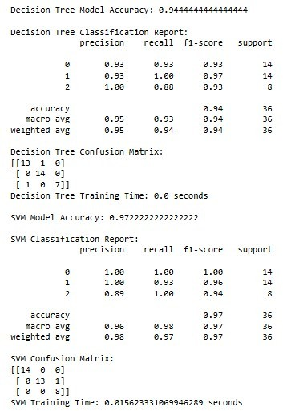
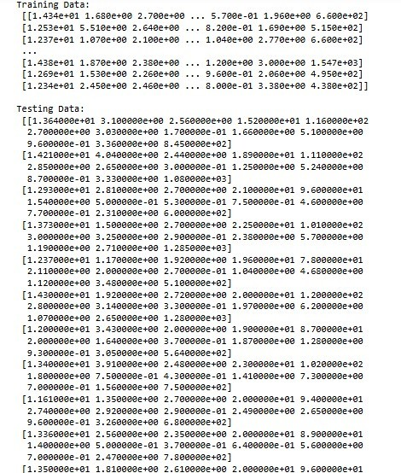
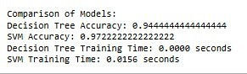

Extra credits:
- Compute and plot feature importance from the Decision Tree model
- Save and load both models
- Experiment with different Decision Tree depths and compare accuracy
- Compute training time for both models
- Display misclassified samples for both models

Code:
import matplotlib.pyplot as plt import numpy as np
import seaborn as sns import joblib
from sklearn.tree import DecisionTreeClassifier from sklearn.metrics import accuracy_score import time
feature_importance = dt_model.feature_importances_ feature_names = data.feature_names plt.figure(figsize=(10, 6)) sns.barplot(x=feature_importance, y=feature_names) plt.title("Feature Importance from Decision Tree") plt.xlabel("Importance")
plt.ylabel("Features") plt.show()
joblib.dump(dt_model, "decision_tree_model.pkl") joblib.dump(svm_model, "svm_model.pkl") loaded_dt_model = joblib.load("decision_tree_model.pkl") loaded_svm_model = joblib.load("svm_model.pkl") print("Models saved and loaded successfully!")
depths = [2, 4, 6, 8, 10, 12]
dt_accuracies = [] for depth in depths:
model = DecisionTreeClassifier(max_depth=depth, random_state=42) model.fit(X_train_scaled, y_train)
y_pred = model.predict(X_test_scaled) acc = accuracy_score(y_test, y_pred) dt_accuracies.append(acc) plt.figure(figsize=(8, 5))
plt.plot(depths, dt_accuracies, marker='o', color='green') plt.xlabel("Decision Tree Depth")

plt.ylabel("Accuracy")
plt.title("Decision Tree Depth vs Accuracy") plt.grid(True)
plt.show()
print("\nTraining Time Comparison:")
print(f"Decision Tree Training Time: {dt_time:.4f} seconds") print(f"SVM Training Time: {svm_time:.4f} seconds") dt_misclassified = np.where(y_test != y_pred_dt)[0] print("\nDecision Tree Misclassified Samples:")
print("Index | Actual | Predicted") for idx in dt_misclassified:
print(idx, " | ", y_test[idx], " | ", y_pred_dt[idx]) svm_misclassified = np.where(y_test != y_pred_svm)[0] print("\nSVM Misclassified Samples:")
print("Index | Actual | Predicted") for idx in svm_misclassified:
print(idx, " | ", y_test[idx], " | ", y_pred_svm[idx])

Output:
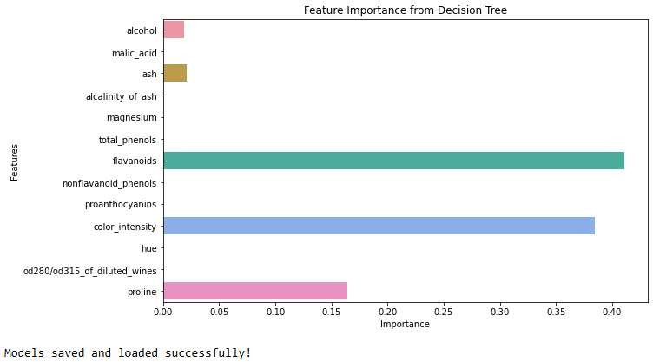
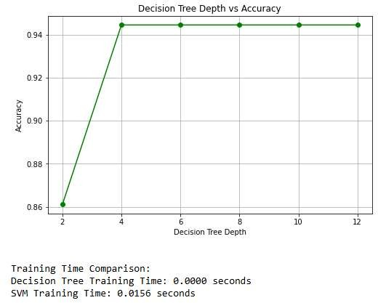
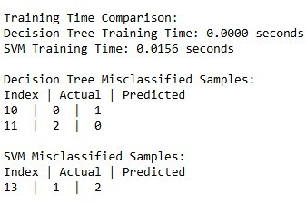

- DECISION TREE REGRESSOR
To Create a Program for Load the Diabetes prediction dataset. Divide the data into training and testing set. Print the training and testing data. Create a Decision Tree Regression model for the dataset and run the model for 500 iterations. Apply Linear Regression to the dataset and print the results. Print the evaluation results and learned model weights. Compare the results with results of Linear regression in terms of speed and accuracy.

Code:
import numpy as np import warnings
warnings.simplefilter('ignore', DeprecationWarning) from sklearn.datasets import load_diabetes
from sklearn.tree import DecisionTreeRegressor from sklearn.model_selection import train_test_split from sklearn.linear_model import LinearRegression from sklearn.preprocessing import StandardScaler
from sklearn.metrics import mean_squared_error, r2_score data = load_diabetes()
x, y = data.data, data.target
x_train, x_test, y_train, y_test = train_test_split(x, y, test_size=0.2, random_state=42) print("Training Data:\n")
print(x_train) print("Testing Data:\n") print(x_test)
print('\n')
scaler = StandardScaler()
x_train_scaled = scaler.fit_transform(x_train) x_test_scaled = scaler.transform(x_test)
dt_model = DecisionTreeRegressor(max_depth=10, random_state=42) dt_model.fit(x_train_scaled, y_train)
y_pred_dt = dt_model.predict(x_test_scaled) dt_mse = mean_squared_error(y_test, y_pred_dt) dt_r2 = r2_score(y_test, y_pred_dt)

print("Decision Tree MSE:\n", dt_mse) print('\n')
print("Decision Tree R2 Score:\n", dt_r2) print('\n')
lin_reg_model = LinearRegression() lin_reg_model.fit(x_train_scaled, y_train) y_pred_lin = lin_reg_model.predict(x_test_scaled) lin_mse = mean_squared_error(y_test, y_pred_lin) lin_r2 = r2_score(y_test, y_pred_lin)
print("Linear Regression MSE:" ,lin_mse) print("Linear Regression R2 Score:", lin_r2) print('\n')
print("Comparison of Models:\n")
print(f"Decision Tree MSE: {dt_mse:.2f} \n R2 Score: {dt_r2:.2f}\n") print(f"Linear Regression MSE: {lin_mse:.2f}\n R2 Score: {lin_r2:.2f}\n") Output:
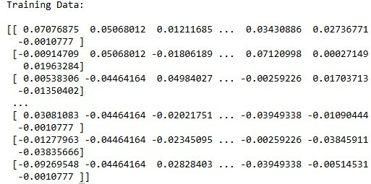
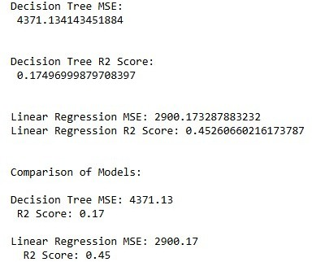
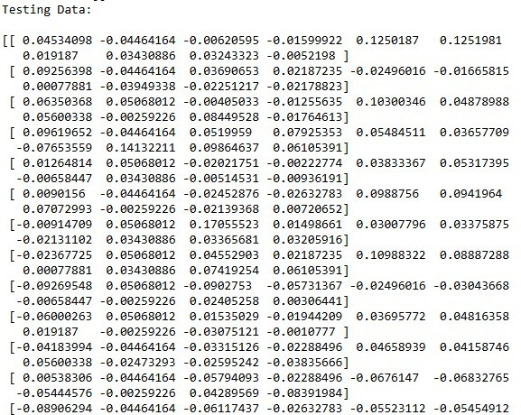

Extra credits:
- Compute and plot feature importance from the Decision Tree model
- Save and load both models
- Experiment with different depths for Decision Tree Regression and compare MSE
- Compute training time for both models
- Display prediction errors for both models

Code:
plt.figure(figsize=(10,6)) sns.barplot(x=dt_model.feature_importances_, y=data.feature_names) plt.title("Feature Importance - Decision Tree") plt.xlabel("Importance")
plt.ylabel("Features") plt.show()
joblib.dump(dt_model, "decision_tree_model.pkl") joblib.dump(lin_reg_model, "linear_regression_model.pkl") dt_loaded = joblib.load("decision_tree_model.pkl") lin_loaded = joblib.load("linear_regression_model.pkl") print("\nModels saved and loaded successfully!")
depths = [2, 4, 6, 8, 10, 12]
mse_scores = []
print("\nDecision Tree Depth vs MSE:") for depth in depths:
model = DecisionTreeRegressor(max_depth=depth, random_state=42) model.fit(X_train_scaled, y_train)
preds = model.predict(X_test_scaled) mse = mean_squared_error(y_test, preds) mse_scores.append(mse)
print(f"Depth {depth} -> MSE: {mse}") plt.figure(figsize=(8,5))
plt.plot(depths, mse_scores, marker='o') plt.xlabel("Tree Depth")

plt.ylabel("Mean Squared Error") plt.title("Decision Tree Depth vs MSE") plt.grid()
plt.show()
dt_errors = y_test - y_pred_dt lin_errors = y_test - y_pred_lin plt.figure(figsize=(10,5)) plt.subplot(1,2,1) sns.histplot(dt_errors, kde=True)
plt.title("Decision Tree Prediction Errors") plt.subplot(1,2,2)
sns.histplot(lin_errors, kde=True) plt.title("Linear Regression Prediction Errors") plt.tight_layout()
plt.show()
Output:
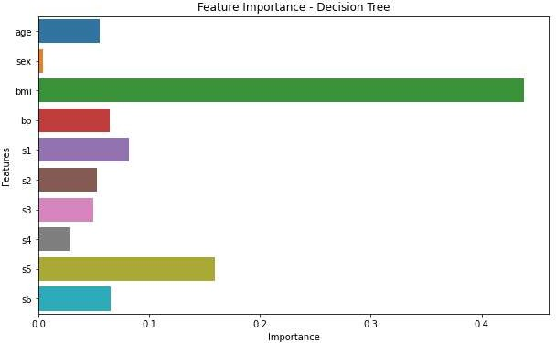
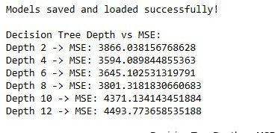

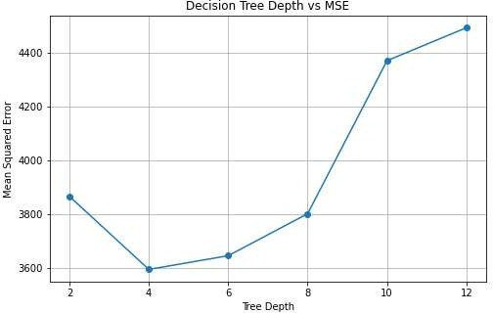
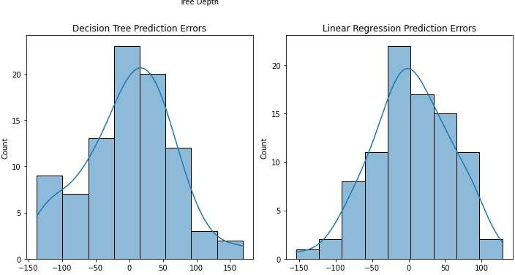

- K-MEANS CLUSTERING
To Create a Program for Populate clustering dataset with 2 features using sklearn built-in functions. Divide the data into training and testing set. Print the training and testing data. Apply K-Means for the dataset and run the model for 500 iterations. Visualize the clustering results using 2D plots.

Code:
%matplotlib inline
import matplotlib.pyplot as plt import numpy as np
import warnings
warnings.simplefilter("ignore", DeprecationWarning) from sklearn.datasets import make_blobs
from sklearn.model_selection import train_test_split from sklearn.cluster import KMeans
from sklearn.preprocessing import StandardScaler import seaborn as sns
X, _ = make_blobs(n_samples=500, centers=3, n_features=2, random_state=42) X_train, X_test = train_test_split(X, test_size=0.2, random_state=42) print("Training Data:")
print(X_train) print("\nTesting Data:") print(X_test)
scaler = StandardScaler()
X_train_scaled = scaler.fit_transform(X_train) X_test_scaled = scaler.transform(X_test)
kmeans = KMeans(n_clusters=3, max_iter=500, random_state=42, n_init=10) kmeans.fit(X_train_scaled)
y_pred_train = kmeans.predict(X_train_scaled) y_pred_test = kmeans.predict(X_test_scaled) plt.figure(figsize=(8, 6))
plt.scatter( X_train_scaled[:, 0],

X_train_scaled[:, 1], c=y_pred_train,
cmap='viridis', marker='o', label="Training Data") plt.scatter(
kmeans.cluster_centers_[:, 0],
kmeans.cluster_centers_[:, 1],c='red',marker='x',s=200,label="Centroids") plt.xlabel("Feature 1")
plt.ylabel("Feature 2")
plt.title("K-Means Clustering Results") plt.legend()
plt.show()
Output:
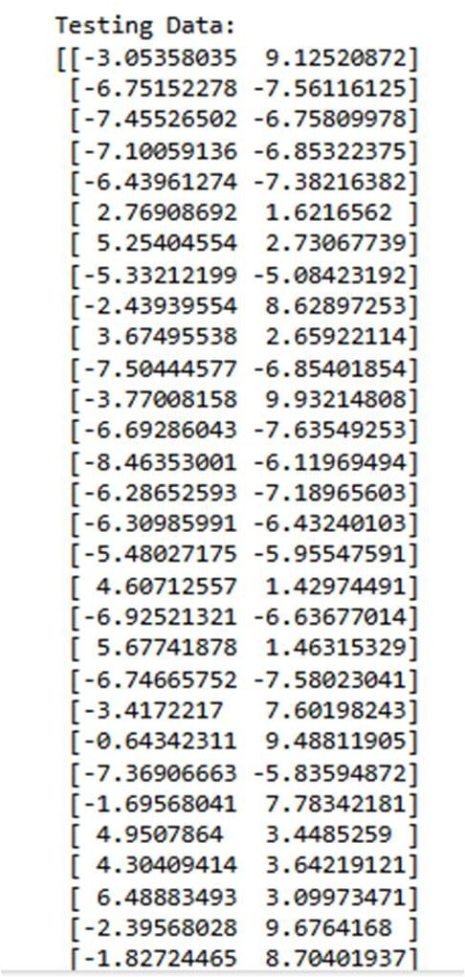
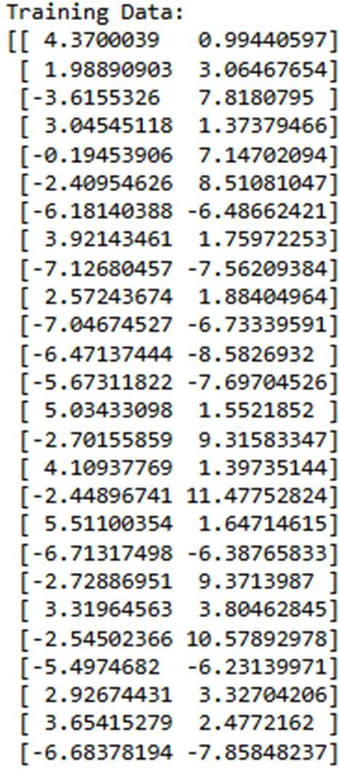

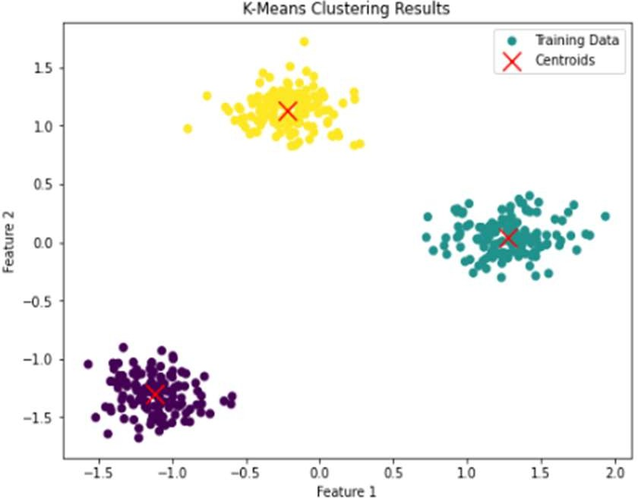

Extra credits:
- Apply the k-means for iris dataset with 3 clusters and compare with logistic regression results
- Compute and display the inertia value (sum of squared distances to closest cluster center)
- Experiment with different numbers of clusters (e.g., 2, 4, 5) and compare inertia values
- Compute the silhouette score to evaluate clustering performance
- Visualize the elbow method to find the optimal number of clusters

Code:
%matplotlib inline import numpy as np
import matplotlib.pyplot as plt import seaborn as sns
import warnings warnings.filterwarnings("ignore") from sklearn.datasets import load_iris
from sklearn.preprocessing import StandardScaler from sklearn.cluster import KMeans
from sklearn.linear_model import LogisticRegression
from sklearn.metrics import accuracy_score, silhouette_score from sklearn.model_selection import train_test_split
iris = load_iris()
X = iris.data y = iris.target
scaler = StandardScaler() X_scaled = scaler.fit_transform(X)
kmeans = KMeans(n_clusters=3, random_state=42, n_init=10) kmeans_labels = kmeans.fit_predict(X_scaled)
X_train, X_test, y_train, y_test = train_test_split( X_scaled, y, test_size=0.2, random_state=42) log_reg = LogisticRegression(max_iter=200)

log_reg.fit(X_train, y_train) y_pred = log_reg.predict(X_test)
logistic_accuracy = accuracy_score(y_test, y_pred) print("---- Comparison ")
print("Logistic Regression Accuracy:", logistic_accuracy)
print("K-Means is unsupervised (no accuracy, evaluated using inertia & silhouette)") print("\n---- Inertia ")
print("Inertia (k=3):", kmeans.inertia_) cluster_values = [2, 3, 4, 5] inertia_values = []
print("\n---- Inertia for Different Clusters ")
for k in cluster_values:
km = KMeans(n_clusters=k, random_state=42, n_init=10) km.fit(X_scaled)
inertia_values.append(km.inertia_) print(f"k = {k}, Inertia = {km.inertia_}")
silhouette_avg = silhouette_score(X_scaled, kmeans_labels) print("\n---- Silhouette Score ")
print("Silhouette Score (k=3):", silhouette_avg) k_range = range(1, 11)
elbow_inertia = [] for k in k_range:
km = KMeans(n_clusters=k, random_state=42, n_init=10) km.fit(X_scaled)
elbow_inertia.append(km.inertia_) plt.figure(figsize=(8, 5))
plt.plot(k_range, elbow_inertia, marker='o') plt.xlabel("Number of Clusters (k)") plt.ylabel("Inertia")
plt.title("Elbow Method for Optimal k") plt.grid(True)
plt.show()

Output:
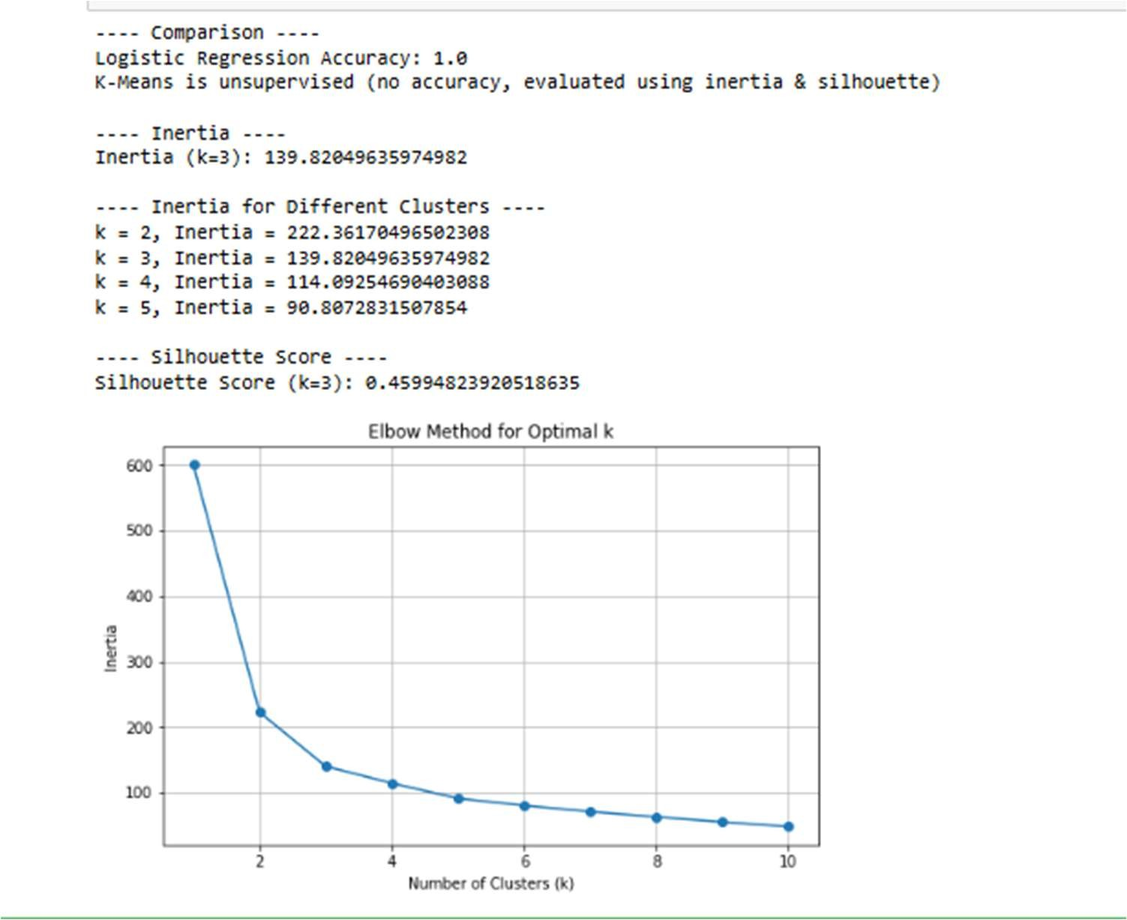

- SPECTRAL CLUSTERING

To Create a Program for Populate clustering dataset with 2 features using sklearn built-in functions. Divide the data into training and testing set. Print the training and testing data. Apply spectral clustering for the dataset and run the model for 500 iterations. Visualize the clustering results using 2D plots. Visually compare the results with plots of the K-means in terms of speed and clustering validity.

Code:
%matplotlib inline
import matplotlib.pyplot as plt import numpy as np
import warnings
warnings.simplefilter("ignore", DeprecationWarning) from sklearn.datasets import make_blobs
from sklearn.model_selection import train_test_split from sklearn.cluster import KMeans, SpectralClustering from sklearn.preprocessing import StandardScaler
from sklearn.metrics import silhouette_score
X, _ = make_blobs(n_samples=500, centers=3, n_features=2, random_state=42) X_train, X_test = train_test_split(X, test_size=0.2, random_state=42) print("Training Data Shape:", X_train.shape)
print("Testing Data Shape:", X_test.shape) scaler = StandardScaler()
X_train_scaled = scaler.fit_transform(X_train) X_test_scaled = scaler.transform(X_test) spectral = SpectralClustering(
n_clusters=3, affinity='nearest_neighbors', assign_labels='kmeans', random_state=42)
y_pred_spectral = spectral.fit_predict(X_train_scaled) plt.figure(figsize=(6, 5))

plt.scatter( X_train_scaled[:, 0],
X_train_scaled[:, 1], c=y_pred_spectral, cmap='viridis',s=30) plt.xlabel("Feature 1")
plt.ylabel("Feature 2") plt.title("Spectral Clustering Results") plt.show()
kmeans = KMeans( n_clusters=3, max_iter=500, n_init=10, random_state=42)
y_pred_kmeans = kmeans.fit_predict(X_train_scaled) plt.figure(figsize=(12, 5))
plt.subplot(1, 2, 1) plt.scatter( X_train_scaled[:, 0],
X_train_scaled[:, 1], c=y_pred_kmeans, cmap='viridis',s=30) plt.title("K-Means Clustering") plt.subplot(1, 2, 2)
plt.scatter( X_train_scaled[:, 0],
X_train_scaled[:, 1], c=y_pred_spectral, cmap='viridis',s=30) plt.title("Spectral Clustering") plt.show()

Output:

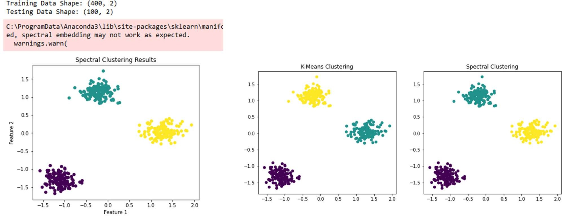

Extra credits:
- Apply the model with Iris Dataset and compare the results with K-means clustering.
- Compute the silhouette score to evaluate Spectral Clustering performance
- Experiment with different numbers of clusters (e.g., 2, 4, 5) and compare results
- Compare the execution time of Spectral Clustering and K-Means
- Visualize the clustering performance using contour plots

Code:
%matplotlib inline import numpy as np
import matplotlib.pyplot as plt import time
import warnings warnings.filterwarnings("ignore") from sklearn.datasets import load_iris
from sklearn.preprocessing import StandardScaler
from sklearn.cluster import KMeans, SpectralClustering from sklearn.metrics import silhouette_score
from sklearn.decomposition import PCA

iris = load_iris()
X = iris.data
scaler = StandardScaler() X_scaled = scaler.fit_transform(X) spectral = SpectralClustering( n_clusters=3, affinity='nearest_neighbors', assign_labels='kmeans', random_state=42)
y_spectral = spectral.fit_predict(X_scaled)
kmeans = KMeans(n_clusters=3, n_init=10, random_state=42) y_kmeans = kmeans.fit_predict(X_scaled)
print("Silhouette Score (Spectral Clustering):", silhouette_score(X_scaled, y_spectral)) print("Silhouette Score (K-Means):", silhouette_score(X_scaled, y_kmeans)) print("\nSpectral Clustering - Different k values:") for k in [2, 4, 5]:
spectral = SpectralClustering( n_clusters=k, affinity='nearest_neighbors', assign_labels='kmeans', random_state=42)
labels = spectral.fit_predict(X_scaled) score = silhouette_score(X_scaled, labels)
print(f"k = {k} | Silhouette Score = {score:.4f}") start = time.time()
SpectralClustering( n_clusters=3, affinity='nearest_neighbors', assign_labels='kmeans',
random_state=42).fit_predict(X_scaled)

spectral_time = time.time() - start start = time.time()
KMeans(n_clusters=3, n_init=10, random_state=42).fit_predict(X_scaled) kmeans_time = time.time() - start
print("\nExecution Time:")
print("Spectral Clustering:", spectral_time, "seconds") print("K-Means:", kmeans_time, "seconds")
pca = PCA(n_components=2)
X_pca = pca.fit_transform(X_scaled)
x_min, x_max = X_pca[:, 0].min() - 1, X_pca[:, 0].max() + 1
y_min, y_max = X_pca[:, 1].min() - 1, X_pca[:, 1].max() + 1
xx, yy = np.meshgrid( np.linspace(x_min, x_max, 300), np.linspace(y_min, y_max, 300)) kmeans_pca = KMeans(n_clusters=3, n_init=10, random_state=42) kmeans_pca.fit(X_pca)
Z = kmeans_pca.predict(np.c_[xx.ravel(), yy.ravel()]) Z = Z.reshape(xx.shape)
plt.figure(figsize=(8, 6))
plt.contourf(xx, yy, Z, cmap='viridis', alpha=0.3)
plt.scatter(X_pca[:, 0], X_pca[:, 1], c=y_kmeans, cmap='viridis', edgecolor='k') plt.xlabel("PCA Feature 1")
plt.ylabel("PCA Feature 2")
plt.title("Clustering Performance Visualization (Contour Plot)") plt.show()

Output:
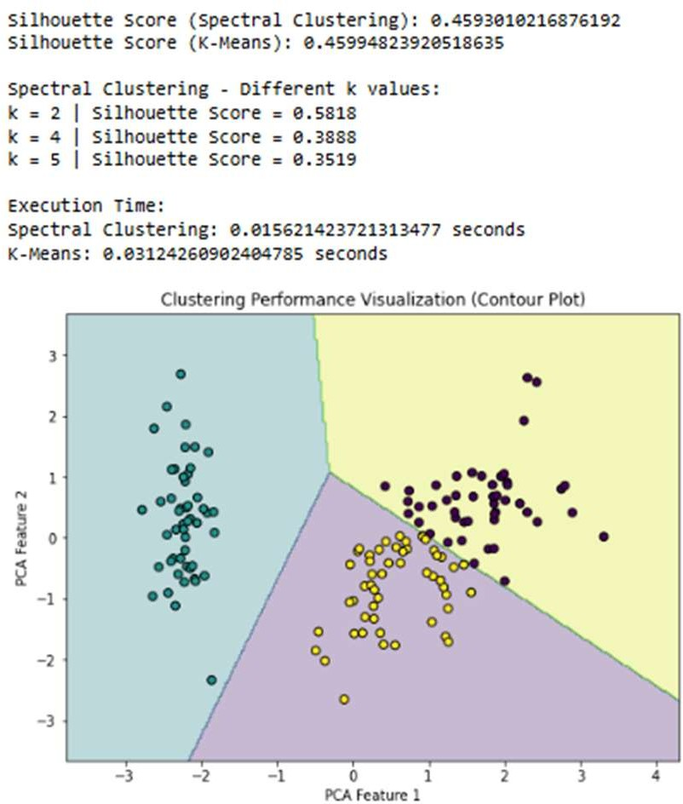

- SIMPLE NEURAL NETWORKS
To Create a Program for Load the Digits classification dataset. Divide the data into training and testing set. Print the training and testing data. Create a Neural Network with 2 layers and 100 nodes each for the dataset and run the model for 500 iterations. Apply logistic regression, SVM, decision tree to the dataset and print the results. Print the evaluation results and learned model weights. Compare the results in terms of speed and accuracy.

Code:
import matplotlib.pyplot as plt import numpy as np
import warnings
warnings.simplefilter("ignore", DeprecationWarning) from sklearn.datasets import load_digits
from sklearn.model_selection import train_test_split from sklearn.neural_network import MLPClassifier from sklearn.linear_model import LogisticRegression from sklearn.svm import SVC
from sklearn.tree import DecisionTreeClassifier from sklearn.preprocessing import StandardScaler from sklearn.metrics import accuracy_score
data = load_digits()
X = data.data y = data.target
X_train, X_test, y_train, y_test = train_test_split( X, y, test_size=0.2, random_state=42)
scaler = StandardScaler()
X_train_scaled = scaler.fit_transform(X_train) X_test_scaled = scaler.transform(X_test) nn_model = MLPClassifier( hidden_layer_sizes=(100, 100), max_iter=500,
random_state=42) nn_model.fit(X_train_scaled, y_train)

y_pred_nn = nn_model.predict(X_test_scaled) nn_accuracy = accuracy_score(y_test, y_pred_nn) logistic_model = LogisticRegression(max_iter=500) logistic_model.fit(X_train_scaled, y_train) y_pred_logistic = logistic_model.predict(X_test_scaled)
logistic_accuracy = accuracy_score(y_test, y_pred_logistic) svm_model = SVC(kernel='linear', max_iter=500) svm_model.fit(X_train_scaled, y_train)
y_pred_svm = svm_model.predict(X_test_scaled) svm_accuracy = accuracy_score(y_test, y_pred_svm)
dt_model = DecisionTreeClassifier(max_depth=10, random_state=42) dt_model.fit(X_train_scaled, y_train)
y_pred_dt = dt_model.predict(X_test_scaled) dt_accuracy = accuracy_score(y_test, y_pred_dt) print("Comparison of Models:")
print(f"Neural Network Accuracy : {nn_accuracy:.4f}") print(f"Logistic Regression Accuracy: {logistic_accuracy:.4f}") print(f"SVM Accuracy : {svm_accuracy:.4f}") print(f"Decision Tree Accuracy : {dt_accuracy:.4f}")

Output:
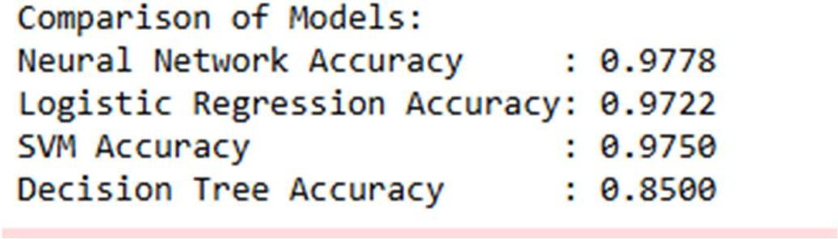
Extra credits:
- Save and load all trained models
- Compute training time for all models
- Display confusion matrices for all models
- Experiment with different hidden layer configurations for Neural Networks
- Visualize feature importance for Decision Tree

Code:
import numpy as np
import matplotlib.pyplot as plt import time
import joblib import warnings
warnings.simplefilter("ignore", DeprecationWarning) from sklearn.datasets import load_digits
from sklearn.model_selection import train_test_split from sklearn.preprocessing import StandardScaler from sklearn.neural_network import MLPClassifier from sklearn.linear_model import LogisticRegression from sklearn.svm import SVC
from sklearn.tree import DecisionTreeClassifier
from sklearn.metrics import accuracy_score, confusion_matrix, ConfusionMatrixDisplay data = load_digits()
X, y = data.data, data.target
X_train, X_test, y_train, y_test = train_test_split( X, y, test_size=0.2, random_state=42)
scaler = StandardScaler()
X_train_scaled = scaler.fit_transform(X_train) X_test_scaled = scaler.transform(X_test) models = {}
training_times = {} accuracies = {}
hidden_layers_list = [(50,), (100,), (100, 100)] for layers in hidden_layers_list:
start = time.time()
nn = MLPClassifier(hidden_layer_sizes=layers, max_iter=500, random_state=42) nn.fit(X_train_scaled, y_train)
end = time.time()
y_pred = nn.predict(X_test_scaled)

acc = accuracy_score(y_test, y_pred) model_name = f"NN_{layers}" models[model_name] = nn training_times[model_name] = end - start accuracies[model_name] = acc
start = time.time()
log_model = LogisticRegression(max_iter=500) log_model.fit(X_train_scaled, y_train)
end = time.time()
models["Logistic Regression"] = log_model training_times["Logistic Regression"] = end - start accuracies["Logistic Regression"] = accuracy_score( y_test, log_model.predict(X_test_scaled))
start = time.time()
svm_model = SVC(kernel='linear', max_iter=500) svm_model.fit(X_train_scaled, y_train)
end = time.time() models["SVM"] = svm_model
training_times["SVM"] = end - start accuracies["SVM"] = accuracy_score( y_test, svm_model.predict(X_test_scaled)) start = time.time()
dt_model = DecisionTreeClassifier(max_depth=10, random_state=42) dt_model.fit(X_train_scaled, y_train)
end = time.time()
models["Decision Tree"] = dt_model training_times["Decision Tree"] = end - start accuracies["Decision Tree"] = accuracy_score( y_test, dt_model.predict(X_test_scaled))
for name, model in models.items(): joblib.dump(model, f"{name}.pkl") print("Models saved successfully!")

loaded_model = joblib.load("Decision Tree.pkl") print("\nModel Performance:")
for name in models:
print(f"{name}")
print(f" Accuracy : {accuracies[name]:.4f}")
print(f" Training Time : {training_times[name]:.4f} seconds") for name, model in models.items():
y_pred = model.predict(X_test_scaled) cm = confusion_matrix(y_test, y_pred)
disp = ConfusionMatrixDisplay(confusion_matrix=cm) disp.plot(cmap="Blues")
plt.title(f"Confusion Matrix - {name}") plt.show()
importances = dt_model.feature_importances_ plt.figure(figsize=(10, 4)) plt.bar(range(len(importances)), importances) plt.title("Feature Importance - Decision Tree") plt.xlabel("Feature Index") plt.ylabel("Importance")
plt.show()

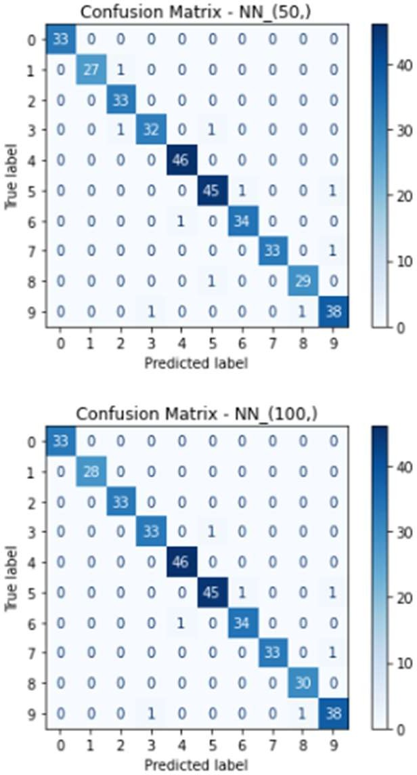
Output:
